**Learn in Community**

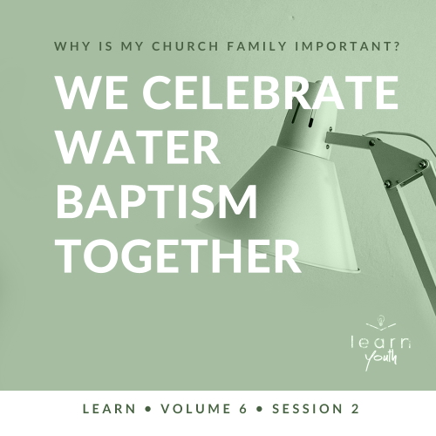

Small Group Study



**Volume Overview**

**Why is my church family important?**

“For where two or three gather together as my followers, I am there among them.” ([Matthew 18:20](https://ref.ly/logosref/Bible.Mt18.20))

*As Christians, we follow Jesus, but we were never meant to follow Jesus by ourself. God gave us a spiritual family to walk with through the highs and lows of life. That family is called the Church! Why is the Church important? What role does the Church play in our life, and what role does each of us play in the Church? This volume will explore questions like these as we investigate what the Bible says about the Church*.

|  |
| --- |
| ***You Will Need***  *• One ream of copier paper*  *• Tape measure or ruler*  *• Smartphone, stopwatch, watch, or clock for a countdown timer*  *• Optional: Small prize for the winning team*  ***Getting Ready***  *• Optional: Talk to a pastor about scheduling a time to hold a baptism service if students are interested in being baptized after learning about it.*  *• Separate the paper into stacks of 25 sheets for each group of 3–5 students.*  *• First time leading* Learn *for Youth? Look here for the* [Facilitator Guide](https://0b769b0ed3569ef9d18b-f88d8272f61086866d50d048b43ef630.ssl.cf2.rackcdn.com/sites/biblengagementproject/Listen_Facilitator_Guide.pdf)*.* |

*To access session content and videos from a computer, visit:*

[*BibleEngagementProject.com/downloads*](https://bibleengagementproject.com/downloads)

**Engage**

**Welcome**

*Take this time to welcome everyone, introduce new students, learn names, and thank everyone for coming*.

|  |
| --- |
| **QUESTION**  What’s your favorite water activity? |

**Opening Prayer**

*Prayer thoughts: Invite students to pray with you instead of just listening to you pray. Thank God for the chance to be together and learn from His Word. Ask Him to open the hearts of students to what He is saying*.

**Introduction**

Today we’re talking about one of the most important water activities of all—water baptism—and why it’s such a big deal in the Church. Being baptized is so much more than just taking a dip or going underwater for a little bit. Water baptism is a spiritual event. Let’s take a look at what baptism really means and why it’s so important for everyone in God’s Church.

**Group Activity**

**Build It Bigger**

|  |
| --- |
| ***You Will Need***  *• One ream of copier paper*  *• Tape measure or ruler*  *• Smartphone, stopwatch, watch, or clock for a countdown timer*  *• Optional: Small prize for the winning team*  ***Getting Ready***  *• Separate the paper into stacks of 25 sheets for each group of 3–5 students.* |

Let’s get started by seeing how well you can work together. You’ll need a team of 3–5 people.

• *Form groups of three to five students and distribute a stack of paper to each group*.

You’ll notice each group has some paper. I’m going to set a five-minute timer. In that time, your group will work together to build a tower with the paper you’ve been given. You can fold it, tear it, or whatever you want. But you can’t use anything in your tower other than paper. The team with the highest tower in the end wins! Are you ready? Then go!

• *After five minutes, measure the height of each tower to determine the winner*.

• *Optional: Give a prize to the winning team*.

Let’s all celebrate the work the winning team did!

|  |
| --- |
| **QUESTION**  What was the strategy for your group? |

|  |
| --- |
| **QUESTION**  What was the hardest part of this activity? |

Activities like this help us to work together. They remind us that we can be better together than on our own. God designed us this way. We weren’t designed to go through life in isolation. So, He gave us the Church as a family to walk through life with.

Today, we’re talking about how water baptism identifies us as a part of the Church—the team known as the body of Christ. Like the activity of building together, we can also encourage one another to build our life on what God’s Word teaches. And as we do that, we can also celebrate our progress together.

**Watch**

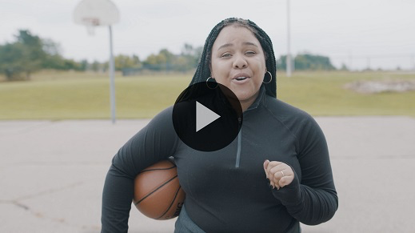

**Consider What the Bible Says**

*Ensure each student has access to a Bible, preferably the same version*.

|  |
| --- |
| **QUESTION**  Has anyone in the group been baptized in water before? If so, can you share what you remember about your experience? |

• *Consider sharing your water baptism experience*.

|  |
| --- |
| **QUESTION**  Before we dive into our discussion, what have you been taught about water baptism and why it’s important? |

Let’s look at what God’s Word has to say about water baptism. Today’s passage comes from the Book of Acts. It focuses on a woman who made the decision to be baptized during the apostle Paul’s second missionary journey.

If you remember from last time, the Church is pretty new. People hadn’t been Christians for very long. So Paul traveled to other cities to start churches or visit churches to share about Jesus and encourage new believers in their faith. As we read and discuss, keep in mind this context of what’s taking place. Let’s dive in and see what we can learn.

**Baptism Follows Salvation**

Read [Acts 16:11–15](https://ref.ly/logosref/Bible.Ac16.11-15).

|  |
| --- |
| **QUESTION**  One of the people Paul met was Lydia. What do we know about Lydia from these verses? |

Lydia was a businesswoman. On this Sabbath day, Lydia worshipped God and met with other worshippers. But she doesn’t appear to know about Jesus yet.

|  |
| --- |
| **QUESTION**  What happened to Lydia just before she and her household were baptized in water? |

Because God opened Lydia’s heart, she put her faith in Jesus after listening to Paul’s teaching. She became a Christian, and she was immediately baptized. We can see in the New Testament that water baptism is one of the first steps someone should take after making a decision to follow Jesus. After someone received Christ, they were usually baptized almost immediately, just like Lydia.

|  |
| --- |
| **QUESTION**  What does this passage show us about someone being a true believer in the Lord? |

After listening to the teachings from Paul regarding Jesus, Lydia made an inner decision. The passage says the Lord opened her heart, and she believed. But she also chose an outward expression of her new faith when she immediately wanted to be baptized.

|  |
| --- |
| **QUESTION**  Do you think that we make water baptism as important today as it was in the New Testament? Why or why not? |

**Baptism Is an Act of Obedience**

Baptism was a huge deal to the earliest Christians, but it was a big deal to Jesus too! He didn’t just tell others to get baptized. He led the way by being baptized himself.

Read [Matthew 3:13–17](https://ref.ly/logosref/Bible.Mt3.13-17).

|  |
| --- |
| **QUESTION**  Why didn’t John want to baptize Jesus? |

|  |
| --- |
| **QUESTION**  Why did Jesus insist on being baptized anyway? |

Isn’t it interesting that Jesus never sinned and didn’t need to repent or be cleansed, yet He still was baptized? When Jesus got baptized, He was identifying with the people that He came to save ([2 Corinthians 5:21](https://ref.ly/logosref/Bible.2Co5.21)). He was also leaving us an example. When we are baptized, we have the chance to identify with Jesus in His death and resurrection.

|  |
| --- |
| **QUESTION**  Why do you think it’s so important for believers to be baptized as soon as possible after accepting Jesus instead of choosing to put it off or ignoring it? |

**Did You Know?**

|  |
| --- |
| Water baptism today is a hands-on event done with two people—one lowering the second individual into the water. But baptism in the days of Jesus was probably slightly different. Two of the earliest artistic depictions of early Christianity show water baptisms. Dated just over one hundred years after the end of the New Testament, these art pieces show the baptizer leading the individual into the water. However, the physical immersion itself was likely carried out by the one being baptized alone. |

**Baptism Is a Symbol of Jesus’ Death and Resurrection**

Read [Romans 6:3–8](https://ref.ly/logosref/Bible.Ro6.3-8).

|  |
| --- |
| **QUESTION**  How does baptism symbolize Jesus’ death, burial, and resurrection? |

|  |
| --- |
| **QUESTION**  What do you think it means for a person’s old, sinful nature to be crucified? |

When we go under the water in baptism, it symbolizes Jesus’ death and burial. It reminds us that our old, sinful ways should end, just like death is an end to life on this earth. And just as Jesus was raised to new life, we come out of the water as a symbol of the new life that we have in Him!

|  |
| --- |
| **QUESTION**  How can water baptism serve as a way to share your faith and your personal salvation story with friends and family who don’t know Jesus? |

**Reflect**

**We Celebrate Water Baptism Together**

New life in Jesus does not end when we pray for salvation. This is only the beginning! The New Testament gives us a pattern to follow—water baptism always follows salvation. Maybe you have already been baptized and today was a reminder of what Jesus has done in your life. Maybe you’ve never been baptized, and this helped you realize that water baptism is your next step. In both cases, water baptism is worthy of celebration. It’s either a reminder of a changed life or the start of one that is changing, and that’s something all Christians should be excited about!

**Listen to God**

Let’s pause and listen to what God might want to say to us about what we have read and shared. Answering the following questions is completely voluntary. These questions are meant to serve as a conversation between you and God. However, you may want to share your response with the group, but no one should feel obligated.

• *Optional: Pause for a few moments of silent reflection before asking students if they want to share*.

|  |
| --- |
| **QUESTION**  How could water baptism help people reflect on the good news that Jesus died and rose from the grave to give them a brand-new life? |

|  |
| --- |
| **QUESTION**  If you’ve never been baptized before, what’s keeping you from doing so? |

**Activate**

One of the simplest steps in your Christian walk should be deciding to be baptized. Jesus called everyone who follows Him to be baptized ([Matthew 28:19](https://ref.ly/logosref/Bible.Mt28.19)). It’s also a great way to talk with your family and friends about your faith and invite them to celebrate with you.

• *Share details about the upcoming water baptism service if one is scheduled soon*.

|  |
| --- |
| **Salvation Opportunity**  *Include this if you think there may be some in the group who do not have a personal relationship with Jesus.*  Just like the story of Lydia showed us, the only prerequisite to water baptism is salvation. So, if you’ve not yet been saved, now is a great time to take that step. Jesus’ death on the Cross paid the price for our sin. His resurrection three days later secured our hope forever. Because of what He did, we can live in freedom, and we can have hope.  **Is there anyone here that we can pray for who doesn’t have a relationship with Jesus or wants to renew their relationship with Him?**  *Take a moment to acknowledge those who respond, and thank them for their desire to make things right between themselves and God. Pray with them as we close in prayer or after the group time is over. Following group time, talk more about where they are in their walk with God and how you might be able to help.* |

**Prayer**

Father God, thank You for Your salvation and what Jesus did on the Cross. If any of us needs to take the step of baptism, help us to choose to do it and be bold in proclaiming what You’ve done in our lives. We pray that believers everywhere would follow You and demonstrate their faith through water baptism. In Jesus’ name I pray. Amen.

**Conclusion**

Every follower of Jesus should follow in His footsteps and be baptized! It’s not an option. Instead, it’s an act of obedience and an outward sign of an inward change that has taken place in your life. Water baptism is a reminder of Jesus’ death and resurrection that gives us hope forever. Is it time for you to take the plunge?

This week, there are personal devotions on the app to help you dive deeper into water baptism. Don’t forget to spend time with those this week! See you next time.